**CA**

[**SUMMARY**](http://www.statemaster.com/graph/bac_sum)**:**

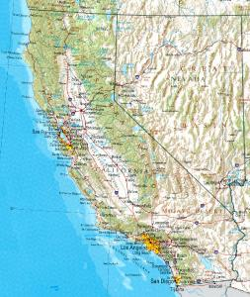Arguably the most diverse geographic state in the nation, California is home to the highest point in the lower 48 (Mount Whitney) and the lowest point in North America (Death Valley), which are a mere 150 miles from each other. California also has some of the oldest and largest trees in the world in the northern Redwood Forests. Earthquake-prone and dotted with volcanoes, California originally included some parts of Nevada, Utah, Wyoming and Arizona, as well as Baja (lower) California in present day Mexico. The regions coastline was explored by Sir Francis Drake in 1579, but it was not until the late 1700's that California was significantly populated by European settlers, the majority of which were Spanish missionaries. Just before the outbreak of the Mexican-American war, the California Republic was declared and the Bear Flag was raised for the first time in the town Sonoma. The new Republic did not last long however, as the U.S. Navy appeared in the San Francisco Bay and declared California a part of the United States. Only a few years later, the Gold Rush struck California, bringing floods of prospectors and adventure seekers into the state. Railroads and road links were established over time (most notably the trans-continental railroad in 1869), turning California into an emerging force in the Union.

[**BACKGROUND**](http://www.statemaster.com/graph/bac_bac)**:**

If California were its own country, it would have the 6th largest economy in the world according to the California Legislative Analyst's Office. The nation’s most populous state has a tremendous effect on American economy, culture, and identity. Los Angeles is the largest city in the state and 2nd largest in the country. Considered an entertainment Mecca, Los Angeles encompasses the city of Hollywood, home to the most powerful cinema industry in the world. Further down the coast, San Diego is one of the fastest growing cities in the U.S. In the north, California is dominated by San Francisco bay area. The region between San Francisco and San Jose, known as 'Silicon Valley', is headquarters to some of the largest software and computer companies in the world. Sacramento, the state capital, is often overshadowed by more powerful Californian cities, but is itself a fast growing urban area. The dominant industry in California is by far agriculture, with exports of fruits, vegetables and wine. Other major industries include aerospace technologies and entertainment. There are major economic disparities between the wealthy coastal areas and some areas of the agricultural interior. California, now a bastion of the liberal Democratic Party, was at one time a largely conservative state. It has sent its 55 electoral votes to the last 4 Democratic presidents however, and Republican politicians in California are often considered moderates on the national scene

AZ

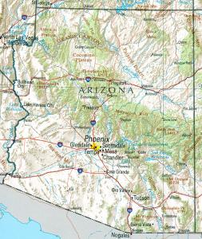[**SUMMARY**](http://www.statemaster.com/graph/bac_sum)**:**

Arizona has been settled continuously for over 12,000 years and the modern city of Tucson is one of the oldest in the nation, founded in 1775. Despite this it was the last of the contiguous states to be admitted to the union on February 14, 1912. The name comes from two words of the language of the Papago Indian; together as "Aleh-zon" they mean 'little spring.' This 'little spring' is located near a large silver discovery on the Arizona creek in Mexico territory. Its history is awash with American legends such as Wyatt Earp, the Apache chief Cochise, Geronimo, and events such as the ‘Gunfight at the OK Corral,’ to name a few. Arizona is renowned for its natural beauty. From the Grand Canyon in the north to the Catalina Mountains in the south, the state is full of world class natural attractions such as Meteor Crater, the Painted Desert, and Monument Valley. These fantastic high desert wonders have served as the back drop to innumerable films and draw visitors from around the world.

[**BACKGROUND**](http://www.statemaster.com/graph/bac_bac)**:**

For much of the last century Arizona’s economy relied heavily on ranching, farming, and mining. Tourism was and continues to be important as well. Today, Arizona produces two-thirds of all the copper in the nation and as of 2001 almost 10 percent of the state’s private-sector workforce was employed in high-tech industries. As reported in 2003, approximately 10 percent of the nation’s Native American population lives within its boarders, making it second only to California in this respect. 25.3% of Arizona’s citizens claim Mexican heritage, according to 2005 estimates. Politically, the state has mostly favored the Republican Party in presidential elections since the 1950’s. The lone exception was the support it lent to incumbent Bill Clinton when it cast its 10 electoral votes to him in 1996.

来源：http://www.statemaster.com/state/CA-california

NM

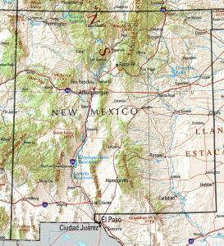[**SUMMARY**](http://www.statemaster.com/graph/bac_sum)**:**

New Mexico takes its name from the anglicized name ‘Neuvo Mexico,’ the name of the area given by the Spanish to the upper Rio Grand, the river which divides the state in two. Occupied for thousands of years by Native Americans, the area’s first European settlers were the Spanish who added it to their territory of New Spain. Later a province of Mexico, it became a state on January 6th, 1912. The Hispanic influence in the area continues to this day and contributes heavily to the state’s unique culture. Geographically, New Mexico is primarily high-desert and is probably best characterized by its moving panoramas, rose-colored deserts, arid mesa steppes, and heavily forested mountains. Notable natural attractions include Carlsbad Caverns National Park, Aztec Ruins National Monument, and White Sands National Monument. Large swaths of land in the southwestern part of the state are dedicated toward missile testing sites and airforce bases.

[**BACKGROUND**](http://www.statemaster.com/graph/bac_bac)**:**

Military research facilities were established in the state during and just after the close of World War II. The Los Alamos Research Center and the Sandia National Laboratories both served to establish the state as the research and development leader in fields such as nuclear, solar and geothermal energy. The first company to develop commercial space flights has placed its headquarters and mission control here. The largest city, Albuquerque, is an economic and transport hub. Santa Fe, the state capital, is often rated as one of the best places in the U.S. to live, with a lively cultural feel and liberal attitude. The peaceful atmosphere and favorable climate have made New Mexico a popular retirement destination for many of America’s elderly. Tourism is an important economic earner, with New Mexico’s natural beauty drawing thousands of visitors every year. Concerning presidential politics, New Mexico has given its electoral votes to all but two presidential winners over the last 94 years – one Republican and one Democrat. In the 2004 election George W. Bush won the state by a margin of a mere 0.8 percent.

来源：http://www.statemaster.com/state/NM-new-mexico

TX

[**SUMMARY**](http://www.statemaster.com/graph/bac_sum)**:**

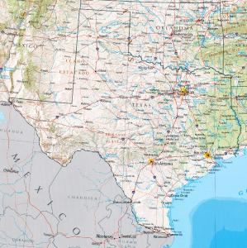Ranked 2nd in both [population](http://www.statemaster.com/graph-T/peo_pop) and [size](http://www.statemaster.com/graph-T/geo_are_lan), Texas is a massive southern state stretching from El Paso in the extreme west to the metropolis of Houston and the cotton fields and historic plantations of Eastern Texas. From north to south, the state extends from the semi-arid terrain of the Texas Panhandle to the Gulf Coast region and the Rio Grande River that forms the border with [Mexico](http://www.nationmaster.com/country/mx). The geography of such a large state obviously varies dramatically, though generally speaking Texas is not an extremely mountainous state (the only debatable exception being The Basin and Range Province, which includes the Big Bend region). The climate tends to become drier and the terrain more rugged as one moves further west. Over the long history of Texas, it was at various times part or whole of six different countries (France, Spain, Mexico, Republic of Texas, the U.S., and the Confederate States of America). Numerous Native American tribes had long settled in the region, and prior to 1821, it was part of the New Spain colony. Texas was then incorporated into newly-independent Mexico, though the restless region could never be fully subdued by the Mexican Government. Slavery and regional rights were at the heart of the issue when Texas ultimately decided to secede from Mexico on March 2nd, 1836 (it was less than 30 years later when Texas decided to secede from the U.S. for similar reasons). After the economic collapse of the budding Texan Republic, the United States admitted Texas into the Union on December 29th, 1845 as the 28th state.

[**BACKGROUND**](http://www.statemaster.com/graph/bac_bac)**:**

More than one third of Texans are of Hispanic origin, contributing much to the culture and economy of the state. The Black population stands at about 11.3%, with the largest communities centered around the eastern portion of the state. Texas is the only state in the U.S. with three cities over one million people - Houston, Dallas and San Antonio. Houston is the largest, and the center of the oil industry. Dallas is a world-renowned manufacturing center and a major transport hub. San Antonio is a lively and multi-cultural city located in the south-central part of the state. Austin, the state capital, is the 4th largest city in Texas and renowned for its music scene. Texas is a world leader in medical research and healthcare, home to the world famous Texas Medical Center where more heart transplants are performed than anywhere else in the world. Once a rural-based economy dependent on cotton farming, Texas has gone through radical changes in the past 6 or 7 decades, becoming a major manufacturing and information technology center, as well as a global leader in oil and gas extraction and processing. Houston has one of the busiest ports in the world, while the Dallas-Ft. Worth area is a major metropolitan area with the 3rd largest airport in the world. [Capital Punishment](http://www.statemaster.com/graph-T/cri_cap_pun_tot_exe) is widely supported in Texas. Over a 27 year period, the state has executed more inmates than the next 5 states combined. Texas is a firmly conservative state, both fiscally and socially, though there are pockets Democratic strongholds. The state unsurprisingly gave fellow Texan and former Governor George W. Bush a wide margin of victory in the 2004 Presidential Elections.

来源：<http://www.statemaster.com/state/TX-texas>

AC

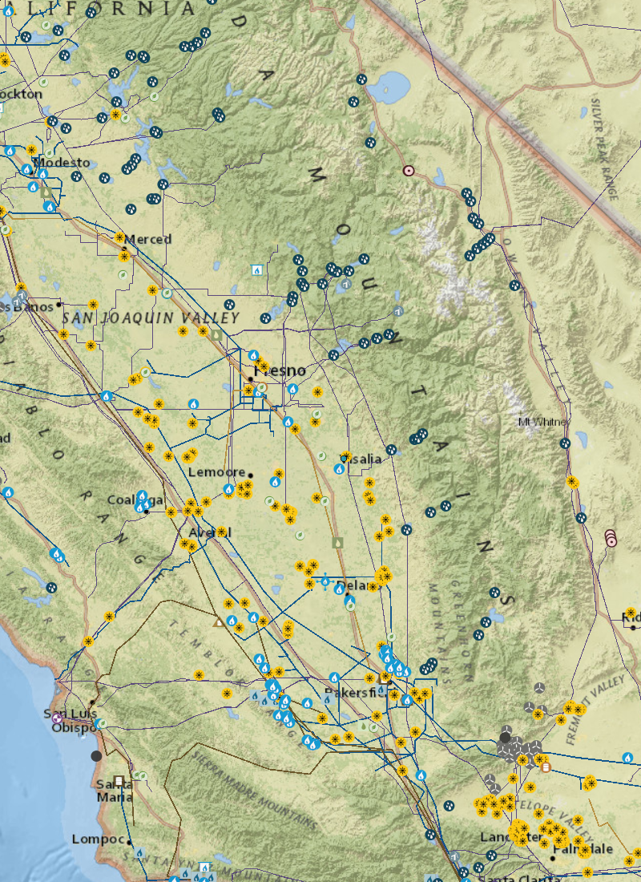

AZ

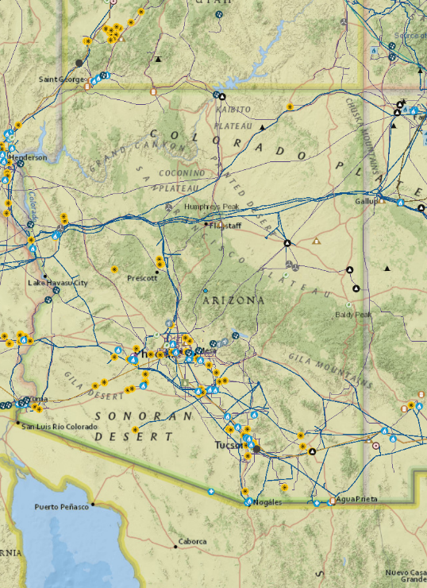

NM

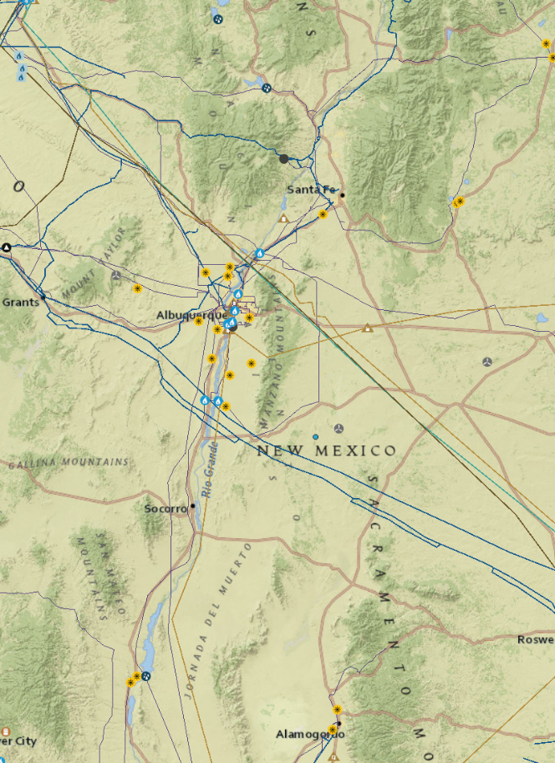

TX

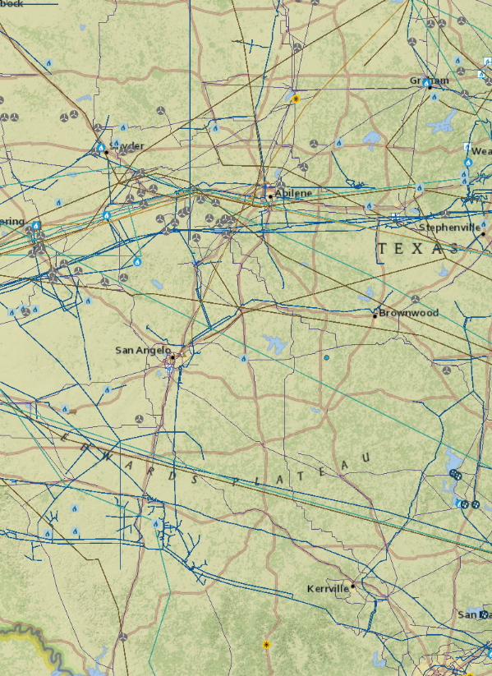

图例：

来源：https://www.eia.gov/state/?sid=CA